Getting Started with MATLAB & Simulink — 2026 Edition

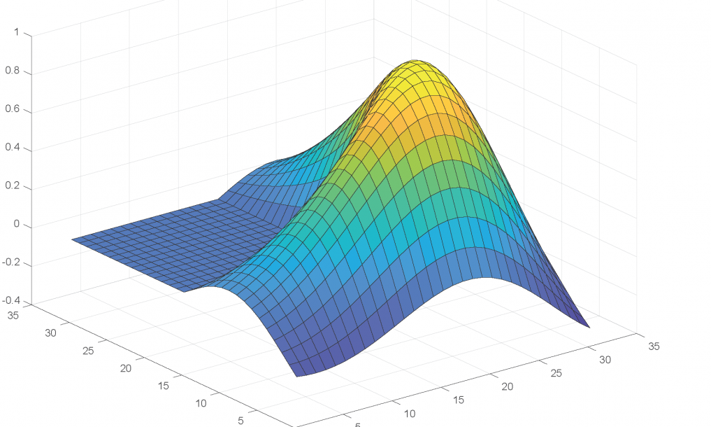

Professor Damian Giaouris
School of Engineering, Newcastle University, damian.giaouris@ncl.ac.uk

Contents

CHAPTER 1: The Basics 3
1.1 Introduction 3
1.2 Simple math 4
1.3 MATLAB and variables 6
1.4 Variables and simple math 7
1.5 Complex numbers 8
1.6 Common mathematical functions 9
1.7 Scripts 10
1.8 Workspace and MAT-files 13
1.9 Toolboxes 13
1.10 Help and documentation 13
Chapter 1 Summary 13
Tutorial Exercise 1: Getting Started with MATLAB 14
CHAPTER 2: Arrays 16
2.1 Array construction and manipulation: simple cases 16
2.2 Matrix operations 18
2.3 Array construction and manipulation: advanced cases 19
2.4 Array searching, comparison and size 20
Chapter 2 summary 23
Tutorial Exercise 2: Working with Arrays 24
CHAPTER 3: Plots 25
3.1 Basic 2D plots 25
3.2 Plotting functions 26
3.3 Adding labels, a title and a grid 26
3.4 Plotting more than one data set 27
3.5 Line styles and markers 28
3.6 Creating more than one plot in a figure 29
3.7 Saving a plot 29
3.8 A brief introduction to 3D plots 29
Chapter 3 summary 31
Tutorial Exercise 3: Plotting Data 32
CHAPTER 4: Logic and Control Flow 33
4.1 Relational operators 33
4.2 Combining conditions 34
4.3 Making decisions with if 35
4.4 Repeating commands with a for loop 36
4.5 Repeating until something changes: while 37
4.6 Combining decisions and loops 37
4.7 Scripts make control flow useful 38
4.8 Introduction to functions 38
4.8.1 Function files and help 39
4.8.2 Function workspaces 39
4.8.3 Functions can call other functions 40
Chapter 4 summary 41
Tutorial Exercise 4: Decisions and Loops 42
CHAPTER 5: Symbolic Manipulation 44
5.1 Symbolic variables 44
5.2 Manipulating symbolic expressions 45
5.3 Solving symbolic equations 45
5.3.1 Solving simultaneous equations 45
5.3.2 A nonlinear equation 46
5.4 Symbolic differentiation 46
5.5 Symbolic integration 47
5.6 Substitution 47
5.7 Solving ordinary differential equations 48
5.7.1 Second-order ODE without initial conditions 48
5.7.2 Third-order ODE with initial conditions 48
5.7.3 Numerical solution with ode45 49
5.8 Symbolic and numerical mathematics 49
Chapter 5 summary 50
Tutorial Exercise 5: Symbolic Mathematics 50
CHAPTER 6: Introduction to Simulink 52
6.1 What is Simulink? 52
6.2 From a differential equation to a block diagram 52
6.3 Starting Simulink 54
6.4 Building the model 55
6.5 Running the simulation and viewing the result 56
6.6 A brief note about solvers 57
6.7 Example: a third-order linear ODE 58
6.8 Example: a first-order nonlinear ODE 60
Chapter 6 summary 61
Tutorial Exercise 6: Your first Simulink model 62

CHAPTER 1: The Basics

1.1 Introduction
MATLAB (short for MATrix LABoratory) is a numerical computing and programming environment widely used in science and engineering. It was originally developed for matrix and numerical computation, but modern MATLAB includes tools for data analysis, visualisation, modelling, simulation, algorithm development and application development.
Typical uses include:
- Math and Computation
- Algorithm development
- Modelling, simulation and prototyping
- Data analysis, exploration and visualisation
- Scientific and engineering graphics
- Application development, including graphical user interface building.
MATLAB is an interactive computing environment whose fundamental data structure is the array. For a complete beginner, a useful way to think about MATLAB is as a very powerful calculator. It can perform ordinary arithmetic and scientific calculations, store results in variables, execute sequences of commands, work with matrices and complex numbers, analyse data, and produce graphical output. Later chapters will introduce arrays, plotting, programming constructs and Simulink.
Start MATLAB using the method provided on your computer or through your institution. The exact layout can differ slightly between MATLAB releases, but the main areas you will use are the Command Window, Workspace, Current Folder and Editor. In the Command Window, commands are entered after the prompt >>.
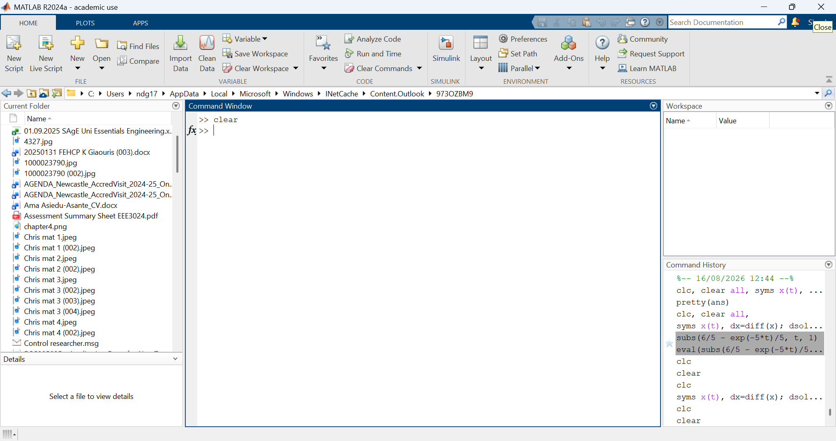
Figure 1: Matlab Window

1.2 Simple math
The first thing that someone can do at the command window is simple mathematic calculations:
» 2+2
ans =
4
» 6-7
ans =
-1
» 1/5
ans =
0.5
» 6*2
ans =
12

The arithmetic operations that we can do are:
Operation | Symbol | Example
Addition, a+b | + | 8+3
Subtraction, a-b | - | 2.05-1.1
Multiplication, a*b | * | 0.15*2.14
Left division, a\b | \ | 3\5
Right division, b/a | / | 5/3(=3\5)
Exponentiation, a^{b} | ^ | 2^5

MATLAB follows the normal mathematical rules of precedence. Exponentiation is evaluated before multiplication and division, which are evaluated before addition and subtraction. Parentheses can be used to make the required order explicit.

1.3 MATLAB and variables
Calculations become much more useful when their results can be stored and reused. MATLAB stores values in variables using the assignment operator “=”.
» a=6
a =
6
» b=7
b =
7
» SSED=5
SSED =
5
» control=2
control =
2
To remove a variable from the workspace, use clear followed by the variable name:
» clear a
Variable names should be meaningful and must follow a few rules:
- A variable name must start with a letter and may then contain letters, digits and underscores. MATLAB is case-sensitive, so A and a are different variables. The maximum identifier length depends on the MATLAB release; type namelengthmax to see the limit in the version you are using.
- MATLAB is case-sensitive; for example, the variable A is different from the variable a.
- Variable names cannot contain spaces and cannot be MATLAB keywords. Type iskeyword to see the complete list of reserved keywords.

MATLAB also provides several predefined names and special values that are useful in calculations. It is normally best not to redefine these names:
Special variable | Value
ans | The default variable name used for results
pi | 3.14…
eps | The smallest possible number such that, when added to one, creates a number greater than one on the computer
inf | Stands for infinity (e.g.: 1/0)
NaN | Not a number (e.g: 0/0)
i (and) j (complex number) | i=j=

MATLAB keywords such as if, else, for, while, switch, case, function, return and end cannot be used as variable names. The command iskeyword displays the complete current list.
The Workspace panel shows the variables currently stored in memory, together with information such as their size, type and value.

1.4 Variables and simple math
The variables that we have just defined can be used, exactly like the numbers:
» d=a+b
d =
13
» f=a*SSED
f =
30

1.5 Complex numbers
MATLAB makes it particularly easy to work with complex numbers. The symbols i and j represent the imaginary unit, although in longer programs it is good practice not to overwrite them with ordinary variable values.
» x=1+j
x =
1.0000 + 1.0000i
» x1=5.36-50i
x1 =
5.3600 -50.0000i
Complex numbers and variables can be used exactly like real numbers and variables.
To transform a complex number from its rectangular form to its polar we use the commands “abs” and “angle”:
» xamp=abs(x)
xamp =
1.4142
» xphase=angle(x)
xphase =
0.7854
The functions sin, cos and tan use angles in radians. If you want to work directly in degrees, MATLAB provides sind, cosd and tand. For example, sin(pi/6) and sind(30) both give 0.5.
To find the real and the imaginary part of a complex number we use the commands “real” and “imag”:
» xreal=(real(x1))
xreal =
5.3600

1.6 Common mathematical functions
MATLAB includes a large collection of built-in mathematical functions. The table below lists a small selection that is useful at this stage. Most functions can operate on both single values and arrays; array operations will be introduced in Chapter 2.
MATLAB name | Comments
abs(x) | Absolute value or magnitude of complex number.
acos(x) | Inverse cosine.
angle(x) | Angle of complex number.
asin(x) | Inverse sine.
atan(x) | Inverse tan.
conj(x) | Complex conjugate.
cos(x) | Cosine.
exp(x) | e^{x}.
imag(x) | Complex imaginary part.
log(x) | Natural logarithm.
log10(x) | Common logarithm.
real(x) | Complex real part.
rem(x,y) | Remainder after division: x/y
round(x) | Round toward nearest integer.
sqrt(x) | Square root.
tan(x) | Tangent

In the Command Window you can recall previous commands using the up and down arrow keys. This is useful when you want to modify and rerun a command rather than type it again.

1.7 Scripts
For a few calculations, entering commands directly in the Command Window is convenient. For a longer sequence of calculations, it is better to place the commands in a script. A script is a file containing MATLAB commands that are executed in order. Standard scripts use the .m extension.
MATLAB also supports Live Scripts, normally saved with the extension .mlx. Live Scripts can combine code, output, equations, formatted text and graphics in one document. They are useful for interactive teaching and reports, but ordinary .m scripts remain the simplest format for learning the basic programming ideas in this course.
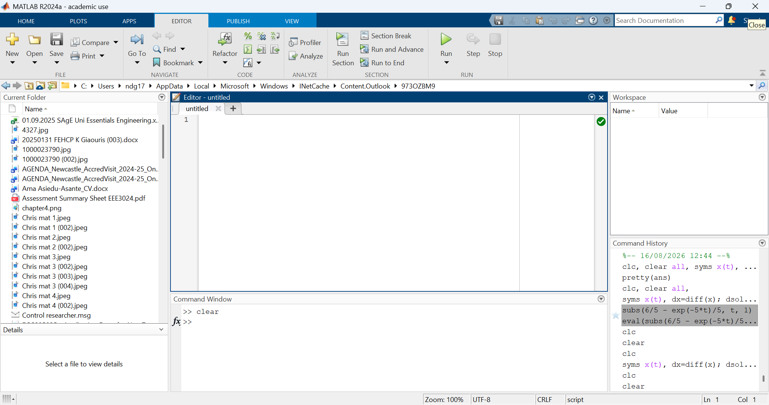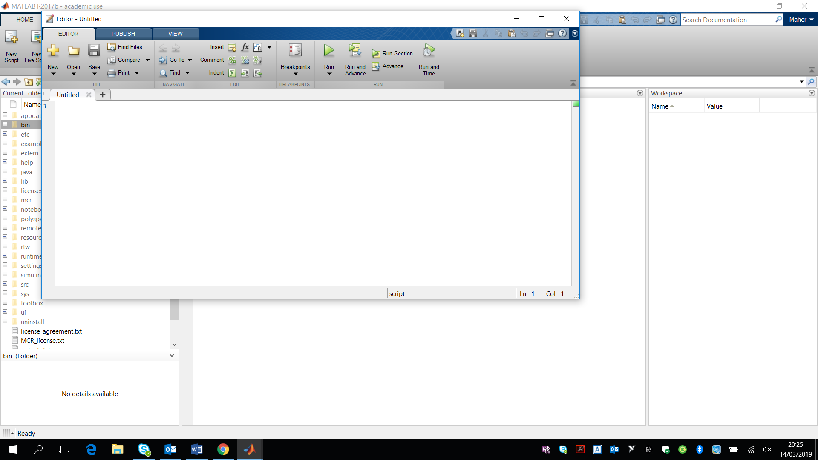
Figure 2: Script window
Create a script from the MATLAB Home tab or Editor, enter your commands, and save it with a meaningful filename in the Current Folder. Run the script using the Run button, F5, or by typing the script name in the Command Window. Interface details vary slightly between releases, so these notes focus on commands rather than the exact position of buttons.
For example, the following script, has the file name “prg1.m” and it creates 2 variables, a and b, assigns them the values of 5 and 10, and then adds them together.
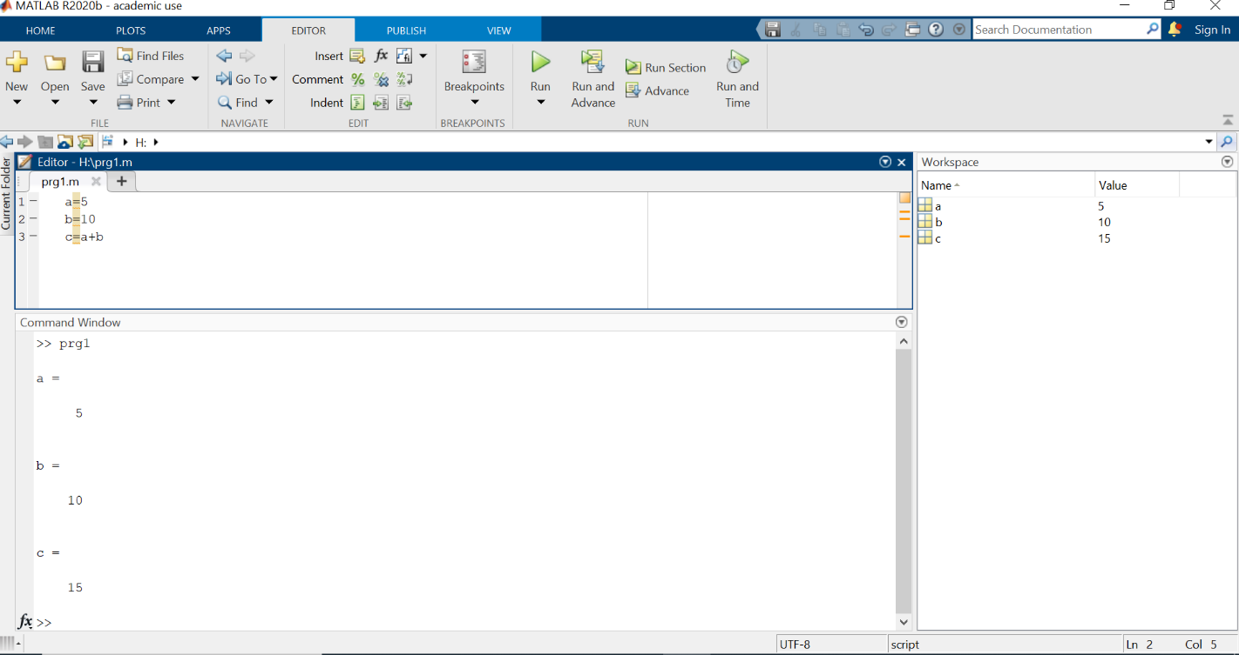
Figure 3 Simple script
Do not give your script the same name as a MATLAB function or one of your variables. MATLAB displays the result of a command by default; place a semicolon (;) at the end of a command when you do not want that intermediate result to be displayed. Suppressing unnecessary output also makes scripts much easier to read. In the previous example, the key point was to find the value od c, so:
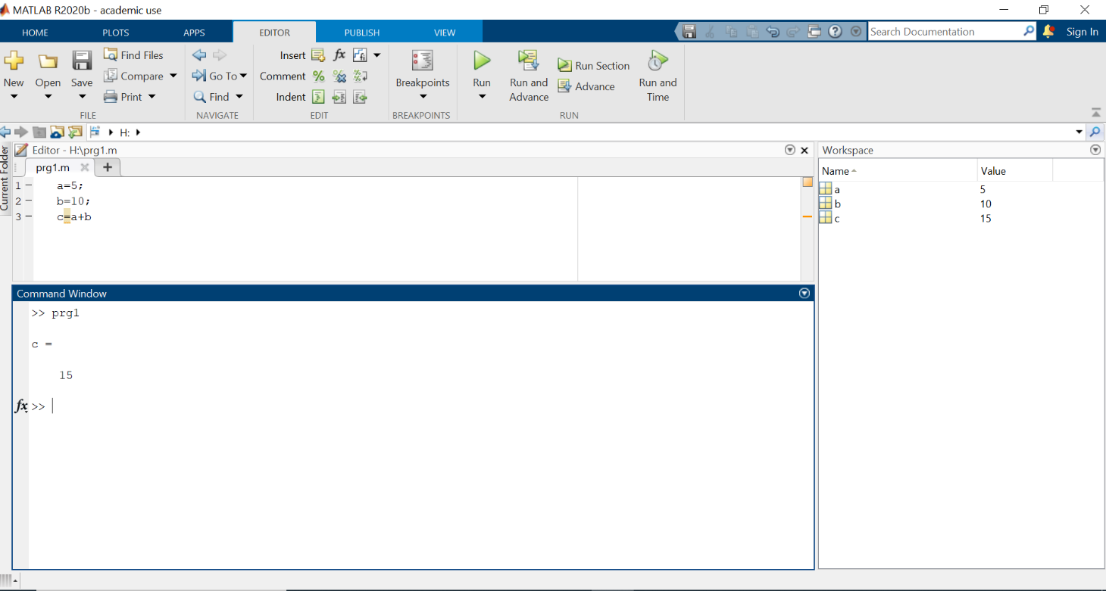
Figure 4 Use of semicolons
Although semicolons may seem unnecessary in very small examples, they become important as scripts grow because they prevent the Command Window from filling with unwanted intermediate output.
A few commands are particularly useful in beginner scripts:
MATLAB name | Comments
disp(x) | Display the value of x without showing the variable name.
disp("Text") | Display text.
input(prompt) | Ask the user to enter a value.
pause | Pause execution until the user continues.
pause(n) | Pause execution for n seconds.
Comments explain what the code is doing and are ignored when the program runs. A MATLAB comment begins with the symbol “%”:
>> temperature=30 % set the temperature
temperature =
30
The idea of using comments, is particularly useful in scripts as it can allow you to explain what different commands are doing and the purpose of the script, for example:
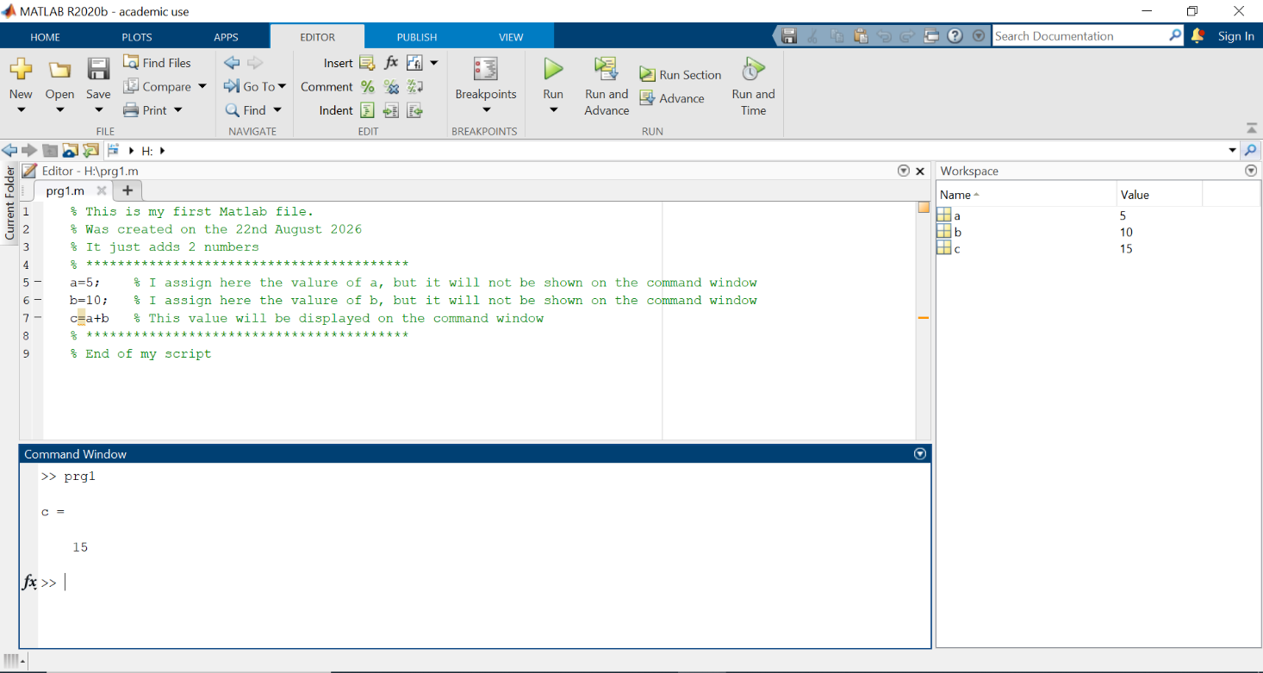
Figure 5 Putting comments in a script

1.8 Workspace and MAT-files
Variables created in the Command Window or by a script are stored in the MATLAB workspace. Use who or whos to list them, and clear to remove variables. If you want to keep variables for another session, save them to a MAT-file with a command such as save("mydata"). Later, restore them using load("mydata"). The Workspace panel provides a graphical view of the same variables.

1.9 Toolboxes
MATLAB can be extended with specialised collections of functions and apps called toolboxes. Different installations may include different toolboxes, depending on the licences available. Examples include Control System Toolbox, Signal Processing Toolbox and Optimization Toolbox. You do not need to know the available toolboxes in detail at this stage.

1.10 Help and documentation
You are not expected to memorise every MATLAB command. MATLAB includes extensive documentation and examples. For quick help in the Command Window, type help followed by the command name, for example help sqrt. You can also search MATLAB Documentation from the Help interface. Learning how to find and interpret documentation is an important MATLAB skill.

Chapter 1 Summary
- MATLAB can be used interactively from the Command Window to perform calculations and execute commands.
- Values can be stored in variables and used in later calculations.
- A semicolon ; at the end of a command suppresses the displayed output.
- Several useful commands help manage a MATLAB session, including clc, clear, who and whos.
- Commands can be stored together in a script, allowing a sequence of calculations to be saved and run again.
- Comments beginning with % can be added to explain MATLAB code and make scripts easier to understand.

Tutorial Exercise 1: Getting Started with MATLAB
Aim: By the end of this exercise, you should be able to perform calculations in MATLAB, create variables, and write and run a simple MATLAB script.
1. Using MATLAB as a calculator
Type the following expressions into the Command Window and check the results:
12 + 7
15 * 4
25 / 4
2^8
sqrt(81)
sin(pi/6)
2. Using variables
A car travels a distance of 150 miles in 2.5 hours.
Create the following variables:
distance = 150;
time = 2.5;
Calculate its average speed and store the answer in a variable called speed.
You should obtain:
speed = 60
Now change distance to 210 miles and calculate the new average speed.
3. Create your first MATLAB script
Create a new script and enter:
distance = 150;
time = 2.5;
speed = distance/time;
disp('The average speed is:')
disp(speed)
Save the script as myfirstscript.m and run it.
You should see:
The average speed is:
60
4. Modify your program
Modify your script so that MATLAB asks the user for the distance:
distance = input('Enter the distance in miles: ');
Run your program and enter 300 when asked for the distance.
What average speed does MATLAB calculate?
5. If you finish early
Add another variable:
time = input('Enter the journey time in hours: ');
Your program should now ask the user for both the distance and the journey time and calculate the average speed.

CHAPTER 2: Arrays
MATLAB is built around arrays. A scalar is a 1-by-1 array, a vector is an array with one row or one column, and a matrix is a two-dimensional array. This chapter develops the same ideas as the original Chapter 2 but uses current MATLAB terminology and recommended practice.

2.1 Array construction and manipulation: simple cases
A row vector can be entered almost exactly as it is written in linear algebra:
>> x = [2 -6 3]
x =
2 -6 3
A second row vector of the same size can be added or subtracted element by element:
>> y = [0 4 9];
>> x + y
ans =
2 -2 12
The operator * means matrix multiplication. Two 1-by-3 row vectors therefore cannot be multiplied using x*y because their dimensions are incompatible for matrix multiplication.
>> x*y
Error using *
Incorrect dimensions for matrix multiplication.
If the intention is to multiply corresponding elements, use the element-wise operator .* :
>> x.*y
ans =
0 -24 27
MATLAB indexing starts at 1. Parentheses select an element:
>> x(3)
ans =
3
An element can also be replaced:
>> x(3) = 8
x =
2 -6 8
Column vectors use semicolons to separate rows:
>> a = [3; 4; 0]
a =
3
4
0
A row vector can be transposed:
>> x'
Note: For real-valued arrays, ' is the usual transpose. For complex arrays, ' also takes the complex conjugate; use .' when only a transpose is required.
Matrices use spaces (or commas) to separate columns and semicolons to separate rows:
>> A = [5 -1; 0 1]
A =
5 -1
0 1

>> B = [4 5; 7 9];
>> A*B
ans =
13 16
7 9
>> A.*B
ans =
20 -5
0 9
Important: A*B is matrix multiplication. A.*B multiplies corresponding elements. The distinction between matrix and element-wise operations is fundamental in MATLAB.

2.2 Matrix operations
MATLAB provides many functions for common matrix calculations. For example:
>> A = [1 2 3; 4 5 6; 7 8 9];
>> det(A)
ans =
0
For a nonsingular matrix, MATLAB can form an explicit inverse using inv:
>> A = [1 5 3; 4 5 10; 7 8 50];
>> Ainv = inv(A);
Recommended practice: Although inv(A) is useful when the inverse itself is required, do not normally solve A*x=b using inv(A)*b. Use x=A\b instead; it is generally faster and more numerically accurate.
Command | Purpose
det(A) | Determinant
eig(A) | Eigenvalues
[V,D] = eig(A) | Eigenvectors and eigenvalues
expm(A) | Matrix exponential
inv(A) | Explicit matrix inverse
norm(A) | Matrix or vector norm
rank(A) | Rank
sqrtm(A) | Matrix square root
trace(A) | Sum of diagonal elements
To solve a system of simultaneous linear equations A*x=b:
>> A = [2 1; 1 3];
>> b = [5; 7];
>> x = A\b
x =
1.6000
1.8000

2.3 Array construction and manipulation: advanced cases
Long regularly spaced vectors should not be typed element by element. The colon operator creates a sequence using the form start:step:end.
>> x = 0:0.1:1
x =
0 0.1000 0.2000 0.3000 0.4000 0.5000 ... 1.0000
If the step is 1, it can be omitted:
>> n = 1:5
n =
1 2 3 4 5
When you want a specified number of equally spaced points, linspace is often clearer:
>> x = linspace(0,1,6)
x =
0 0.2000 0.4000 0.6000 0.8000 1.0000
The colon operator is also used for indexing:
>> x = 0:0.1:1;
>> x(1:3)
ans =
0 0.1000 0.2000
>> x(1:3) = 2;
>> x(1:5)
ans =
2.0000 2.0000 2.0000 0.3000 0.4000
The keyword end refers to the last index:
>> x(end)
ans =
1
>> x(4:end)
Functions operate naturally on vectors:
>> x = (0:0.1:1)*pi;
>> y = cos(x);
Useful functions for constructing arrays include:
Command | Result
eye(3) | 3-by-3 identity matrix
zeros(2,3) | 2-by-3 array of zeros
ones(2,3) | 2-by-3 array of ones
rand(2,3) | 2-by-3 array of uniformly distributed random values
randn(2,3) | 2-by-3 array of normally distributed random values
Random numbers: The exact values returned by rand and randn normally change each time the commands are run, so examples should not rely on a particular set of random values.

2.4 Array searching, comparison and size
Relational expressions such as x>1 return logical values (true or false). In modern MATLAB, logical indexing is usually the simplest way to select values that satisfy a condition.
>> x = -3:3
x =
-3 -2 -1 0 1 2 3

>> x(abs(x)>1)
ans =
-3 -2 2 3
Use find when the positions (indices) themselves are required:
>> k = find(abs(x)>1)
k =
1 2 6 7
Logical indexing also works with matrices:
>> A = [1 2 3; 4 5 6; 7 8 9];
>> A(A>5)
ans =
7
8
6
9
If row and column subscripts are required, find can return them:
>> [i,j] = find(A>5)
i =
3
3
2
3
j =
1
2
3
3
Arrays can be compared directly:
>> B = [1 5 6; 9 0 0; 4 5 1];
>> isequal(A,B)
ans =
logical
0
>> isequal(A,A)
ans =
logical
1
Use size to determine the dimensions of an array:
>> A = [1 2 3 4; 5 6 7 8];
>> size(A)
ans =
2 4
>> [rows,cols] = size(A)
rows =
2
cols =
4
numel returns the total number of elements:
>> numel(A)
ans =
8
About length: length(A) is still valid MATLAB, but it returns the size of the largest dimension. For matrices, size(A,1), size(A,2), or numel(A) usually communicates the intention more clearly.

Chapter 2 summary
- Use square brackets to create vectors and matrices.
- MATLAB indices start at 1.
- Use * for matrix multiplication and .* for element-wise multiplication.
- Use the colon operator to create sequences and to select ranges of array elements.
- Use logical indexing to select values that satisfy a condition; use find when you need the index positions.
- Use size for array dimensions and numel for the total number of elements.
- Use A\b rather than inv(A)*b when solving a linear system.

Tutorial Exercise 2: Working with Arrays
Aim: Create and manipulate vectors and matrices, use indexing, and perform simple array calculations.
1. Create and examine a vector
The temperatures measured at midday over seven days were:
14 16 15 18 21 20 17
Create a row vector called temperature containing these values.
Use MATLAB to display the temperature on day 4 and then display the temperatures from days 2 to 5.
2. Modify the vector
The temperature recorded on day 7 was entered incorrectly. Change it from 17 to 19.
Display the complete temperature vector to check the change.
3. Perform calculations
Create a second row vector called evening containing:
9 11 10 12 14 13 12
Create a vector called difference containing the midday temperature minus the evening temperature for each day.
You should obtain:
5 5 5 6 7 7 7
4. Create and access a matrix
Create a 2-by-7 matrix called temperatures whose first row contains the midday temperatures and whose second row contains the evening temperatures.
Use MATLAB to display:
a) both temperatures recorded on day 3;
b) all midday temperatures;
c) the size of the matrix.
5. If you finish early
Display only the midday temperatures that are greater than 18.
Then create a vector called squared_evening containing the square of every evening temperature. Be careful to use the correct operator.

CHAPTER 3: Plots
One of MATLAB's most useful features is the ease with which numerical data can be visualised. This chapter introduces the essential commands needed to create clear two-dimensional plots, combine data sets, label and format a graph, save a figure, and create a simple three-dimensional plot.

3.1 Basic 2D plots
Suppose that the temperatures measured in a room on three occasions are:
>> t = [19 18 20];
>> plot(t)
When plot is given only one vector, MATLAB uses the element numbers 1, 2, 3, ... for the horizontal axis.
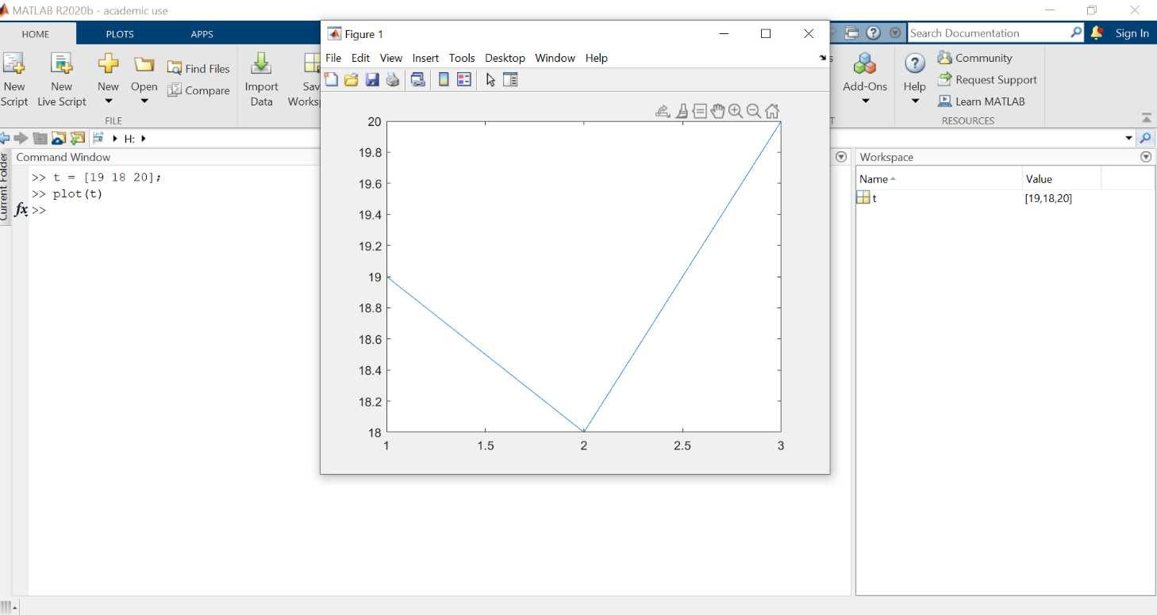
Figure 6 Simple plot command

Usually the horizontal values have a physical meaning. If the measurements were taken at 10:00, 11:00 and 12:00, enter the x-values explicitly:
>> time = [10 11 12];
>> plot(time,t)
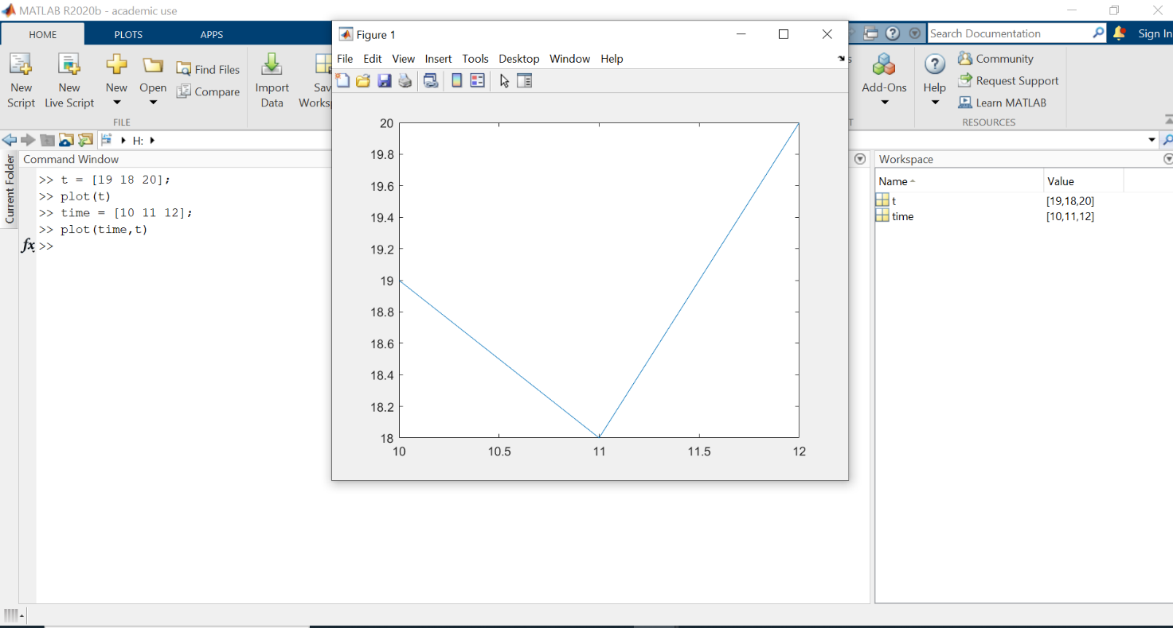
Figure 7 Plot command, with 2 inputs

Important: For plot(x,y), x and y must contain compatible numbers of data points.

3.2 Plotting functions
Arrays from Chapter 2 make it easy to plot mathematical functions. Create the x-values first, calculate the corresponding y-values, and then plot them.
>> x = 0:0.05:2*pi;
>> y = sin(x);
>> plot(x,y)
A smaller step gives more points and therefore a smoother-looking curve. The same idea works for experimental or measured data: x and y are simply arrays of coordinates.

3.3 Adding labels, a title and a grid
A graph should normally explain what its axes represent. MATLAB provides simple commands for this:
>> plot(time,t)
>> xlabel('Time (hour)')
>> ylabel('Temperature (degrees C)')
>> title('Room temperature')
>> grid on
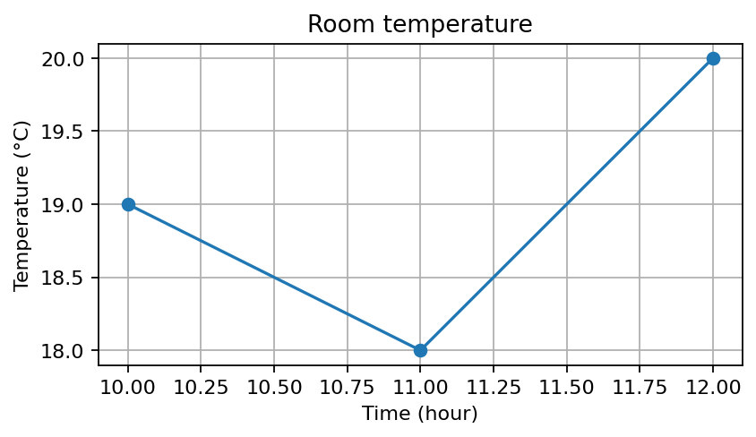
Figure 8 Labels and axes

Axis limits can be changed when necessary:
>> xlim([9.5 12.5])
>> ylim([17 21])
Good practice: Do not change the limits merely to make a trend look larger or smaller. Choose limits that help the reader interpret the data honestly.

3.4 Plotting more than one data set
More than one curve can be drawn with a single plot command:
>> x = 0:0.05:2*pi;
>> y1 = sin(x);
>> y2 = cos(x);
>> plot(x,y1,x,y2)
>> legend('sin(x)','cos(x)')
>> xlabel('x')
>> ylabel('Value')
>> grid on
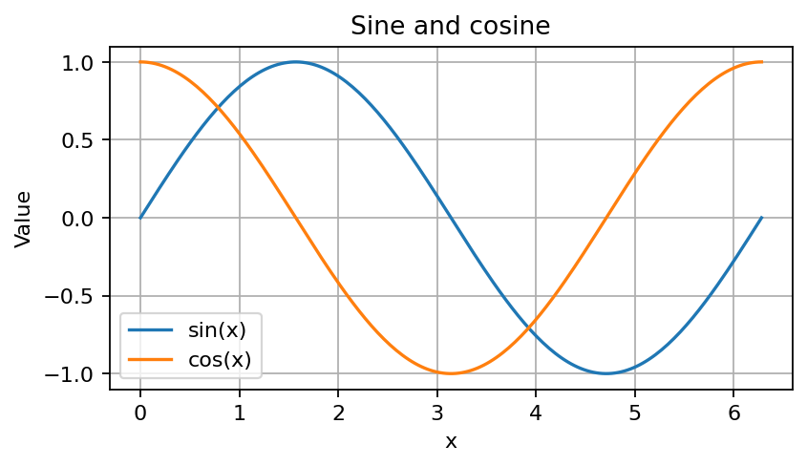
Figure 9 Multiple trace in one figure

Alternatively, hold on keeps the existing plot while another curve is added:
>> plot(x,y1)
>> hold on
>> plot(x,y2)
>> hold off
Important: Without hold on, a new plot command normally replaces the existing plot in the current axes.

3.5 Line styles and markers
The appearance of a curve can be specified directly in the plot command. For example:
>> plot(x,y1,'--')
>> plot(x,y1,'o')
>> plot(x,y1,'-o')
MATLAB also accepts colour specifications, but for a first course it is usually better to concentrate on readable line styles, markers, labels and legends rather than memorising formatting codes.
Properties can also be given by name, which is often clearer:
>> plot(x,y1,'LineWidth',2)
>> plot(x,y1,'Marker','o')

3.6 Creating more than one plot in a figure
When several related graphs should be shown in the same figure without drawing them on the same axes, modern MATLAB provides tiledlayout and nexttile:
>> x = 0:0.05:2*pi;
>> tiledlayout(2,1)
>> nexttile
>> plot(x,sin(x))
>> title('Sine')
>> nexttile
>> plot(x,cos(x))
>> title('Cosine')
Note: Older MATLAB notes often use subplot for this purpose. subplot still works, but tiledlayout gives more control over spacing and layout and is the preferred approach for new code.

3.7 Saving a plot
Plots can be copied interactively, but menus and buttons change between MATLAB releases. A more reproducible method is to export the figure from the command line:
>> exportgraphics(gcf,'temperature.png','Resolution',300)
This saves the current figure as a high-resolution PNG file. Other formats such as PDF and SVG are also available in current MATLAB releases.
Why this is useful: A command can be repeated exactly and included in a script, whereas a sequence of mouse clicks is harder to reproduce.

3.8 A brief introduction to 3D plots
Three-dimensional curves can be produced with plot3. For example, the following commands create a helix:
>> t = 0:pi/50:10*pi;
>> plot3(sin(t),cos(t),t)
>> grid on
>> xlabel('x')
>> ylabel('y')
>> zlabel('t')
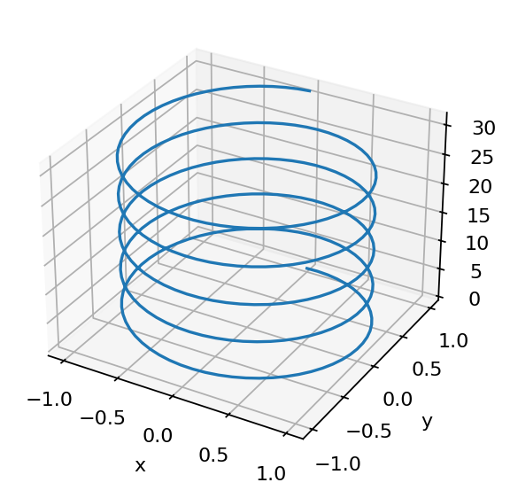
Figure 10 3D plot

MATLAB also includes functions such as surf and mesh for surfaces. These are useful, but they are beyond what is needed for this introductory chapter.
What about graphics object handles?
The original version of this chapter contained a long section on object handles, findobj, get and set. Graphics handles are still an important part of MATLAB, but the old presentation is no longer suitable for an introductory course.
Modern MATLAB plotting functions return graphics objects directly. For example:
>> p = plot(x,y);
>> p.LineWidth = 2;
This is useful later when writing more advanced plotting code, apps or reusable functions. For a student who is just learning plot, arrays, labels and legends, however, the full graphics-object hierarchy would add complexity without helping them create their first useful graphs.
For this course: The detailed object-handle section has therefore been removed from the core chapter. The two-line example above is enough to show that plot properties can be changed programmatically without introducing the full graphics-object model.

Chapter 3 summary
- plot(y) plots values against their element numbers.
- plot(x,y) lets you specify both horizontal and vertical coordinates.
- xlabel, ylabel, title, grid and legend make plots easier to interpret.
- Use hold on / hold off when adding curves with separate plot commands.
- Use line styles and markers when they improve readability.
- Use tiledlayout and nexttile for several related axes in one figure.
- exportgraphics provides a reproducible way to save a plot.
- plot3 gives a simple introduction to three-dimensional plotting.

Tutorial Exercise 3: Plotting Data
Aim: Create a clear MATLAB plot from a small set of measured data and add the information needed to interpret it.
The data
A sensor recorded the temperature of a drink once every minute:
Time (min): 0 1 2 3 4 5 6
Temperature (C): 82 71 63 56 51 47 44
Your task
1. Create a row vector called time containing the measurement times.
2. Create a row vector called temperature containing the measured temperatures.
3. Plot temperature against time.
4. Add the x-axis label Time (min) and the y-axis label Temperature (degrees C).
5. Add the title Cooling of a drink and turn the grid on.
6. Change the plot so that a marker is shown at every measured data point.
Your final graph should make it immediately clear what was measured and when.
If you finish early
A second drink was measured at the same times and gave:
78 69 61 55 50 46 43
Add the second data set to the same axes and add a legend with the labels Drink 1 and Drink 2.

CHAPTER 4: Logic and Control Flow
The first three chapters used MATLAB mainly as a calculator, an array-processing tool and a plotting package. We now take the first real step into programming: making decisions and repeating commands. These ideas allow a program to behave differently depending on its data.

4.1 Relational operators
A relational expression asks a question. MATLAB answers with a logical value: true (1) or false (0).
Operator | Meaning
< | Less than
<= | Less than or equal to
> | Greater than
>= | Greater than or equal to
== | Equal to
~= | Not equal to
>> temperature = 22;
>> temperature > 20
ans =
logical
1
>> temperature == 18
ans =
logical
0
Important: Use = to assign a value and == to compare values. For example, x=5 stores 5 in x, whereas x==5 asks whether x is equal to 5.
Relational operators also work naturally with arrays:
>> A = 1:9;
>> A > 4
ans =
1×9 logical array
0 0 0 0 1 1 1 1 1
This connects directly with the logical indexing introduced in Chapter 2:
>> A(A>4)
ans =
5 6 7 8 9

4.2 Combining conditions
Sometimes one test is not enough. Logical operators combine or reverse conditions.
Operator | Meaning
& | AND: both conditions are true
| | OR: at least one condition is true
~ | NOT: reverses true and false
&& | Short-circuit AND for scalar conditions
|| | Short-circuit OR for scalar conditions
>> A = 1:9;
>> (A>2) & (A<6)
ans =
1×9 logical array
0 0 1 1 1 0 0 0 0
For a single decision in an if or while statement, && and || are often clearer because the condition is scalar:
>> age = 20;
>> (age >= 18) && (age <= 65)
ans =
logical
1
Useful functions: any(condition) is true if at least one element satisfies a condition; all(condition) is true if every element does.

4.3 Making decisions with if
The if statement executes commands only when a condition is true. This is the most important control-flow structure for a beginner.
temperature = 28;
if temperature > 25
disp('The room is warm')
end
If two outcomes are possible, use else:
mark = 62;
if mark >= 40
disp('Pass')
else
disp('Fail')
end
For several alternatives, use elseif:
mark = 72;
if mark >= 70
disp('First')
elseif mark >= 60
disp('2:1')
elseif mark >= 50
disp('2:2')
elseif mark >= 40
disp('Third')
else
disp('Fail')
end
Why the order matters: MATLAB tests the conditions from top to bottom and stops at the first one that is true. Therefore the highest boundary is tested first in this example.

4.4 Repeating commands with a for loop
A for loop is useful when we know how many times a group of commands should be repeated.
for n = 1:5
disp(n)
end
The loop variable n takes the values 1, 2, 3, 4 and 5 in turn. A loop can also store calculated values:
x = zeros(1,5);
for n = 1:5
x(n) = n^2;
end
x
The result is:
x =
1 4 9 16 25
Preallocation: zeros(1,5) creates the required array before the loop. This is good programming practice when a loop fills an array.
MATLAB often allows an array calculation to replace a simple loop:
>> n = 1:5;
>> x = n.^2
x =
1 4 9 16 25
Modern MATLAB: Do not assume that every for loop is 'bad' or must be removed for speed. Vectorised array expressions are often shorter and clearer, but modern MATLAB executes many loops efficiently. Choose the form that makes the calculation easiest to understand.

4.5 Repeating until something changes: while
A while loop is useful when we do not know in advance exactly how many repetitions will be required. It continues while its condition remains true.
value = 1;
while value < 20
value = value*2;
end
value
The value becomes 2, 4, 8, 16 and finally 32. At that point value<20 is false, so the loop stops.
Be careful: A while loop must eventually make its condition false. Otherwise it can continue indefinitely. If this happens while experimenting, use MATLAB's Stop button or Ctrl+C.

4.6 Combining decisions and loops
The real usefulness of control flow appears when loops and decisions are combined. The following program examines the temperatures from Chapter 3 and reports the first measurement above 25 degrees C:
temperature = [18 20 23 27 29];
for n = 1:length(temperature)
if temperature(n) > 25
fprintf('Measurement %d is above 25 degrees C\n',n)
break
end
end
break exits the loop immediately after the first value satisfying the condition has been found.
Connection with earlier chapters: For many array-searching problems, logical indexing is still simpler than writing a loop. Here the loop is shown because the purpose is to learn program flow, not because it is the shortest possible MATLAB solution.

4.7 Scripts make control flow useful
Control-flow statements are normally most useful inside a script rather than being typed line by line in the Command Window. A script can contain calculations, decisions, loops and plots and can then be run again whenever the data change.
% Simple classification script
mark = 68;
if mark >= 70
result = 'First';
elseif mark >= 60
result = '2:1';
else
result = 'Other';
end

disp(result)
This also reinforces the idea from Chapter 1 that comments beginning with % should be used to explain the purpose of code.

4.8 Introduction to functions
MATLAB already contains many functions, such as abs, sqrt, mean and inv. A function receives one or more input values, performs a calculation, and can return one or more output values. We can also create our own functions. This helps us organise a program into smaller, reusable pieces.
Suppose we want a function that adds two arrays. Create a new function file containing:
function z = fun1(x,y)
%FUN1 Add two arrays.
% Z = FUN1(X,Y) returns the sum X + Y.
z = x + y;
end
Save the file as fun1.m. Then, from the Command Window or from another script:
>> a = [1 1; 2 2];
>> b = [3 3; 4 4];
>> outcome = fun1(a,b)
outcome =
4 4
6 6
Here x and y are the input arguments, z is the output argument, and fun1 is the function name. The values stored in a and b are passed into the function and the result is returned to outcome.

4.8.1 Function files and help
When a function is stored in its own file, the file name should match the function name. Therefore the function fun1 is saved in fun1.m. The comment block immediately below the function definition can be displayed using help:
>> help fun1
This makes the first comments in a function particularly useful: they can explain what the function does, what inputs it expects and what it returns.

4.8.2 Function workspaces
Each function has its own workspace. Variables created inside a function are normally local to that function and do not appear in the base MATLAB workspace when the function finishes.
function y = doubleValue(x)
temp = 2*x;
y = temp;
end
If we call result = doubleValue(5), the function returns 10. The local variables x and temp belong to the function workspace; the normal connection with the calling workspace is through the function inputs and outputs.

4.8.3 Functions can call other functions
A function can use MATLAB's built-in functions and can also call functions that you have written:
function z = rootOfDouble(x)
y = doubleValue(x);
z = sqrt(y);
end
Breaking a larger calculation into small functions can make a program easier to understand, test and reuse.
For this course: We will pass information into functions using input arguments and return information using output arguments. MATLAB also provides global variables, but they are deliberately not introduced here because explicit inputs and outputs usually make beginner programs clearer and easier to debug.

Chapter 4 summary
- Relational operators such as >, <=, == and ~= produce logical values.
- Logical operators combine conditions.
- if / elseif / else allows a program to make decisions.
- for repeats commands a known number of times.
- while repeats commands while a condition remains true.
- Loops and decisions can be nested or combined.
- Logical indexing may be simpler than a loop for many array operations.
- Control flow becomes particularly useful when it is placed in scripts.
- Functions package calculations into reusable blocks with explicit inputs and outputs.

Tutorial Exercise 4: Decisions and Loops
Aim: Use relational tests, an if statement and a for loop to analyse a small set of measurements.
The data
A sensor recorded the following temperatures:
temperature = [18 21 24 27 29 23];
A temperature above 25 degrees C will be treated as HIGH.
Your task
1. Enter the temperature vector shown above.
2. Use the expression temperature>25 to see which measurements are HIGH.
3. Create a variable called currentTemperature and set it equal to 27.
4. Write an if/else statement that displays HIGH if currentTemperature is greater than 25, and NORMAL otherwise.
5. Write a for loop that examines every value in temperature. For each measurement, display HIGH if it is above 25 and NORMAL otherwise.
For step 5, your output should contain six messages: NORMAL, NORMAL, NORMAL, HIGH, HIGH, NORMAL.
6. Turn the decision into a function
Create a function called checkTemperature that receives one temperature as its input and returns 1 if the temperature is above 25 degrees C and 0 otherwise.
Start with:
function status = checkTemperature(t)
% Your if/else statement goes here
end
Save it as checkTemperature.m and test it using:
>> checkTemperature(27)
>> checkTemperature(21)
You should obtain 1 for 27 degrees C and 0 for 21 degrees C.
If you finish early
Modify the loop so that it also displays the measurement number. For example:
Measurement 1: NORMAL
Measurement 4: HIGH
Hint: fprintf can include an integer using %d.

CHAPTER 5: Symbolic Manipulation
Up to this point, most MATLAB variables have contained numerical values. MATLAB can also work with mathematical symbols and exact expressions. Symbolic calculations are provided by Symbolic Math Toolbox, which must be installed to run the commands in this chapter.
Numerical versus symbolic: A numerical calculation produces a numerical approximation. A symbolic calculation can preserve variables, fractions, roots and mathematical expressions exactly.

5.1 Symbolic variables
A normal numerical variable stores a value:
>> x = 10
x =
10
To tell MATLAB that a name represents a mathematical symbol, use syms:
>> syms x
>> g=x
Now we have created the variable g (as before), but now g does not have a numerical value, but a symbolic one, x.
>> f = x^2 + 2*x + 1
f =
x^2 + 2*x + 1
Now, we can treat the variable f, as a function or, in this case, polynomial of x.
Several symbolic variables can be declared together:
>> syms x y z
>> d = x^2 + cos(y) - sqrt(49*z)
MATLAB now treats x, y and z as symbols rather than as numerical values.
Current syntax: Older MATLAB notes often passed equations to solve as quoted text. Modern symbolic code should normally create symbolic variables first and use symbolic expressions directly.

5.2 Manipulating symbolic expressions
Symbolic expressions can be expanded, factorised and simplified.
>> syms x
>> expand((x+1)^3)
ans =
x^3 + 3*x^2 + 3*x + 1
>> factor(x^2-1)
ans =
[x - 1, x + 1]
simplify attempts to rewrite an expression in a simpler form:
>> simplify((x^2-1)/(x-1))
Mathematical assumptions: Symbolic simplification can depend on assumptions about variables and on where an expression is defined. For this introductory chapter, we will use simple examples where the intended result is clear.

5.3 Solving symbolic equations
The solve function finds exact symbolic solutions when possible. Notice that an equation uses ==, not =:
>> syms a x
>> xsol = solve(a*x == 10,x)
xsol =
10/a
This connects with Chapter 4: = assigns a value, whereas == expresses equality.

5.3.1 Solving simultaneous equations
>> syms x y
>> sol = solve([x+y == 10, x-y == 4],[x y]);
>> sol.x
ans =
7
>> sol.y
ans =
3
The two solutions are returned as fields of sol because two unknown variables were requested.

5.3.2 A nonlinear equation
solve is not restricted to linear equations:
>> syms x
>> sol = solve(x^2 - 5*x + 6 == 0,x)
sol =
2
3
The symbolic result is exact. More complicated equations may have several solutions or may not have a simple closed-form symbolic solution.

5.4 Symbolic differentiation
The diff function differentiates a symbolic expression:
>> syms x
>> f = x^3 + sin(x);
>> df = diff(f,x)
df =
3*x^2 + cos(x)
Higher derivatives can be requested directly:
>> d2f = diff(f,x,2)
If an expression contains several symbolic variables, specify the variable with respect to which the differentiation is required:
>> syms x y
>> f = x^2*y + sin(y);
>> diff(f,x)
>> diff(f,y)

5.5 Symbolic integration
The int function performs symbolic integration. An indefinite integral is:
>> syms x
>> int(x^2,x)
ans =
x^3/3
A definite integral includes the lower and upper limits:
>> int(sin(x),x,0,pi)
ans =
2
Note: As usual with indefinite integration, MATLAB returns an antiderivative; an arbitrary constant of integration is not displayed.

5.6 Substitution
subs replaces a symbolic variable by a value or another expression:
>> syms x
>> f = x^2 + 2*x + 1;
>> subs(f,x,3)
ans =
16
Substitution can also be symbolic:
>> syms a
>> subs(f,x,a+1)

5.7 Solving ordinary differential equations
MATLAB can also solve ordinary differential equations (ODEs). The symbolic function dsolve attempts to return an exact mathematical expression. Initial conditions may be supplied when they are known; without them, MATLAB returns a general solution containing arbitrary constants.

5.7.1 Second-order ODE without initial conditions
Consider the second-order differential equation d²x/dt² + 5 dx/dt + 6x = 0. First define x as a symbolic function of time and form its derivatives:
>> syms x(t)
>> dx = diff(x,t);
>> d2x = diff(x,t,2);
>> xsol = dsolve(d2x + 5*dx + 6*x == 0)
xsol =
C1*exp(-2*t) + C2*exp(-3*t)
Because no initial conditions were specified, the answer is the general solution and contains two arbitrary constants, C1 and C2. A second-order ODE requires two independent conditions to determine them.

5.7.2 Third-order ODE with initial conditions
Now consider the third-order equation d³x/dt³ + 6 d²x/dt² + 11 dx/dt + 6x = 0, with x(0)=1, x'(0)=0 and x''(0)=0:
>> syms x(t)
>> dx = diff(x,t);
>> d2x = diff(x,t,2);
>> d3x = diff(x,t,3);
>> xsol = dsolve(d3x + 6*d2x + 11*dx + 6*x == 0, ...
x(0) == 1, dx(0) == 0, d2x(0) == 0)
xsol =
3*exp(-t) - 3*exp(-2*t) + exp(-3*t)
A third-order ODE needs three independent initial conditions to determine a unique solution. Here dsolve uses the three conditions to eliminate all arbitrary constants.

5.7.3 Numerical solution with ode45
For numerical ODE solutions, MATLAB provides solvers such as ode45. A first-order example is kept here because it shows the basic numerical syntax without introducing the additional step of converting a higher-order ODE into a system of first-order equations:
>> odefun = @(t,x) -5*x + 6;
>> [t,xnum] = ode45(odefun,[0 2],1);
>> plot(t,xnum)
>> xlabel('Time')
>> ylabel('x(t)')
>> grid on
dsolve returns a symbolic formula when possible, whereas ode45 returns approximate numerical values at a sequence of time points.

5.8 Symbolic and numerical mathematics
It is useful to distinguish two different questions:
% Symbolic: what is the exact integral?
>> syms x
>> int(exp(-x^2),x,0,1)
% Numerical: what decimal value does it have?
>> double(int(exp(-x^2),x,0,1))
Symbolic calculations preserve mathematical structure; numerical calculations produce numbers that can be used directly in subsequent numerical processing and plotting.
For this course: The aim is not to cover symbolic mathematics in depth. The important skill is knowing that MATLAB can create and manipulate symbolic expressions, solve equations, differentiate, integrate and then convert results to numerical values when required.

Chapter 5 summary
- syms creates symbolic variables; expand, factor and simplify manipulate symbolic expressions.
- solve finds exact symbolic solutions when possible.
- diff and int perform symbolic differentiation and integration.
- subs substitutes values or expressions, and double converts symbolic numerical results to floating-point values.
- dsolve solves ODEs symbolically when possible; ode45 calculates numerical ODE solutions.

Tutorial Exercise 5: Symbolic Mathematics
Aim: Create and manipulate a symbolic expression, differentiate and integrate it, solve an equation, and evaluate a symbolic result.
1. Create a symbolic expression
Create the symbolic variable x and then define:
f = x^2 - 5*x + 6
Use factor to factorise f. You should obtain factors corresponding to (x-2)(x-3).
2. Solve an equation
Solve the equation f=0 for x using solve. Remember that MATLAB uses == when writing an equation.
You should obtain the two solutions x=2 and x=3.
3. Differentiate
Use diff to find df/dx.
4. Integrate
Use int to find the indefinite integral of f with respect to x.
5. Substitute a value
Use subs to evaluate f when x=4. You should obtain 2.
6. Solve higher-order differential equations
a) Solve the second-order ODE
d²x/dt² + 5 dx/dt + 6x = 0
without initial conditions. Start with:
syms x(t)
dx = diff(x,t);
d2x = diff(x,t,2);
Use dsolve and check that the answer contains two arbitrary constants.
b) Now solve the third-order ODE
d³x/dt³ + 6 d²x/dt² + 11 dx/dt + 6x = 0
with the initial conditions x(0)=1, x'(0)=0 and x''(0)=0.
You should obtain:
x(t) = 3*exp(-t) - 3*exp(-2*t) + exp(-3*t)
If you finish early
Also solve the same ODE numerically over 0 <= t <= 2 using:
odefun = @(t,x) -5*x + 6;
[t,xnum] = ode45(odefun,[0 2],1);
Plot xnum against t. Does the solution approach the steady value 6/5?

CHAPTER 6: Introduction to Simulink

6.1 What is Simulink?
Simulink is a graphical environment for modelling, simulating and analysing dynamic systems. Instead of writing all equations as MATLAB commands, we connect blocks that represent mathematical operations, signals and system components. It is widely used for control systems, signal processing, power and energy systems, communications and many other engineering applications.
In this introductory chapter we will use Simulink for one simple task: numerically simulating an ordinary differential equation (ODE). You do not need to know the numerical algorithms used internally in order to build and run this first model.

6.2 From a differential equation to a block diagram
Consider the initial-value problem
dx/dt + 5x = 6, x(0) = 1
Analytical solution from Chapter 5
Before building the Simulink model, we can use the symbolic methods from Chapter 5 to obtain the exact solution. This gives us a reference against which the numerical Simulink result can be checked.
>> syms x(t)
>> dx = diff(x,t);
>> xsol = dsolve(dx + 5*x == 6, x(0) == 1)
xsol =
6/5 - exp(-5*t)/5
Thus the analytical solution is x(t) = 6/5 - exp(-5t)/5. It starts from x(0)=1 and tends to 6/5 = 1.2 as time increases.
Rearrange it so that the derivative is on the left:
dx/dt = 6 - 5x
This form tells us exactly what the model needs. We calculate 6 - 5x, integrate the result to obtain x, and feed x back through a gain of -5.
The four blocks we need
- Constant — generates the value 6.
- Sum — adds the signals entering the block.
- Gain — multiplies x by -5.
- Integrator — integrates dx/dt to produce x. Its initial condition is set to 1.
- Scope — displays x as a function of time.
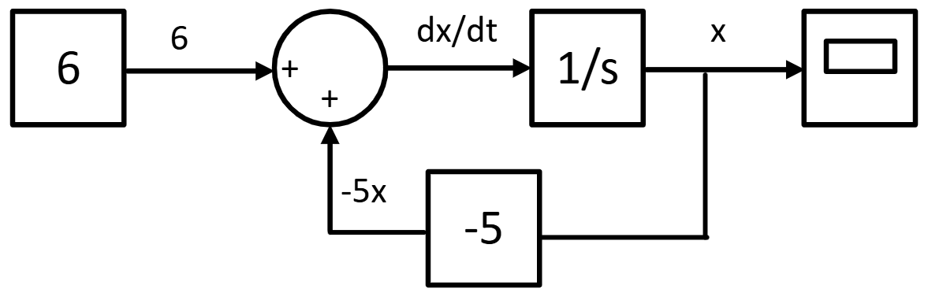
Figure 11 Block diagram of an ODE

The feedback connection is important: the current value of x is used to calculate its own rate of change. This is a very common structure in dynamic-system models.

6.3 Starting Simulink
Start Simulink from MATLAB and create a Blank Model. The exact appearance of the start page can vary slightly between MATLAB releases, but the basic workflow is the same.
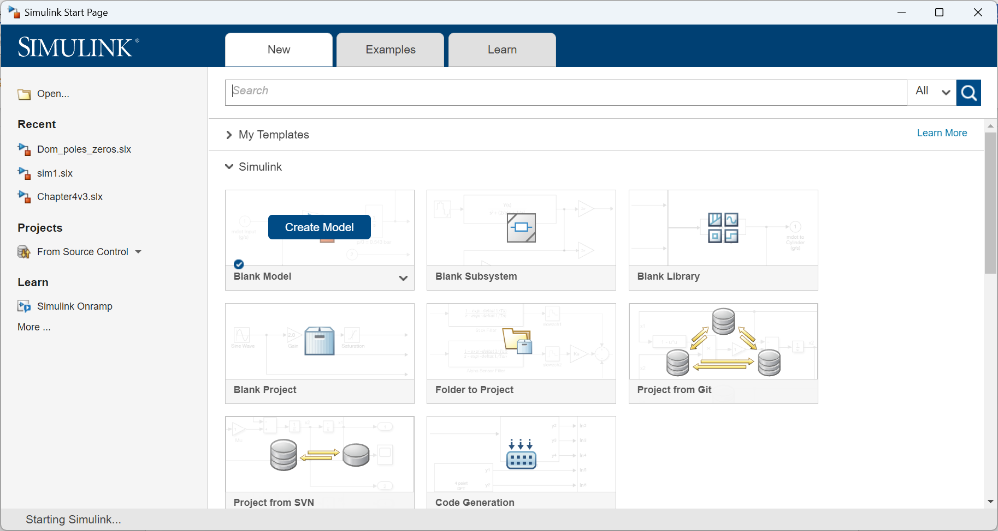
Figure 12 Starting page of Simulink
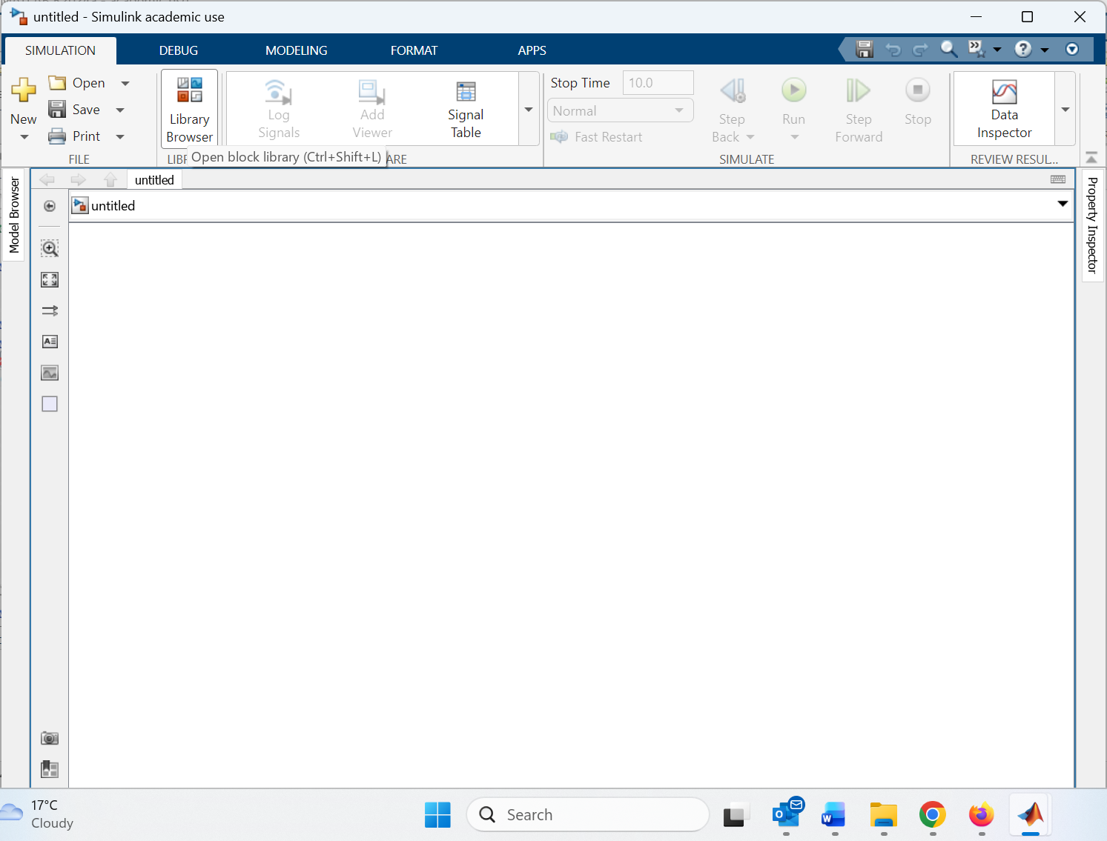
Figure 13 New empty Simulink file

Blocks can be added from the Library Browser. You can browse the libraries or use the search box to find a block by name. For this model, the Integrator is under Simulink > Continuous; Sum and Gain are under Math Operations; Constant is under Sources; and Scope is under Sinks.

6.4 Building the model
1. Add an Integrator block and set its Initial condition to 1.
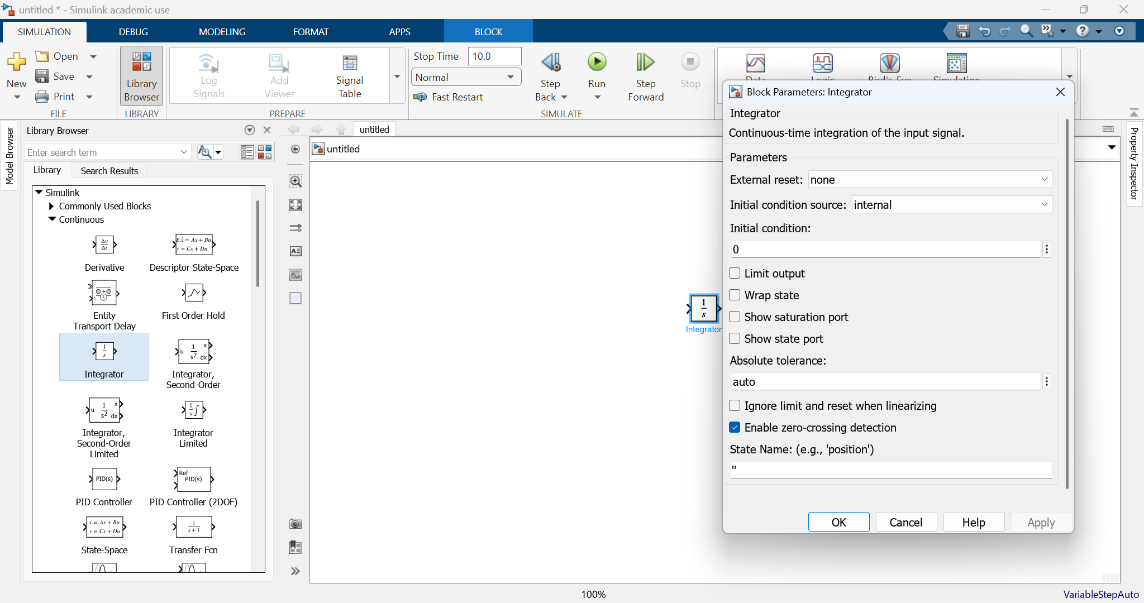
Figure 14 How to add a block in Simulink

2. Add a Sum block and a Gain block. Set the Gain value to -5.
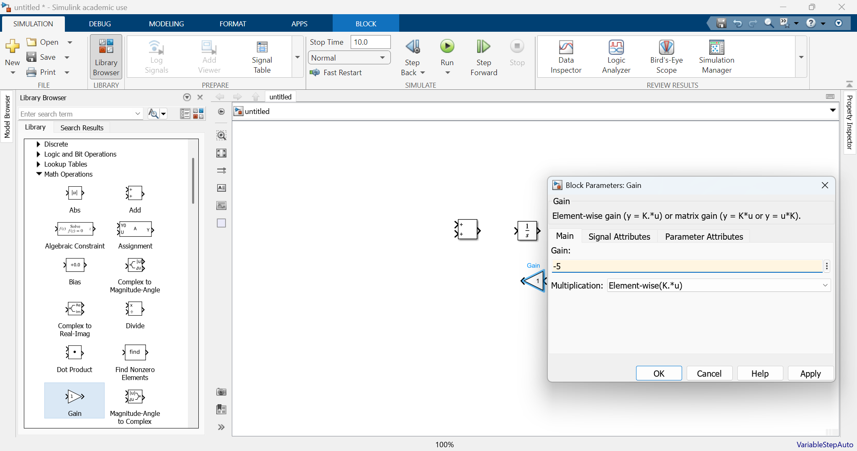
Figure 15 Change properties of blocks

3. Add a Constant block and set its value to 6. Add a Scope block.

4. Connect the blocks so that the Constant and feedback signals enter the Sum, the Sum output enters the Integrator, and the Integrator output x is sent both to the Scope and back through the Gain.
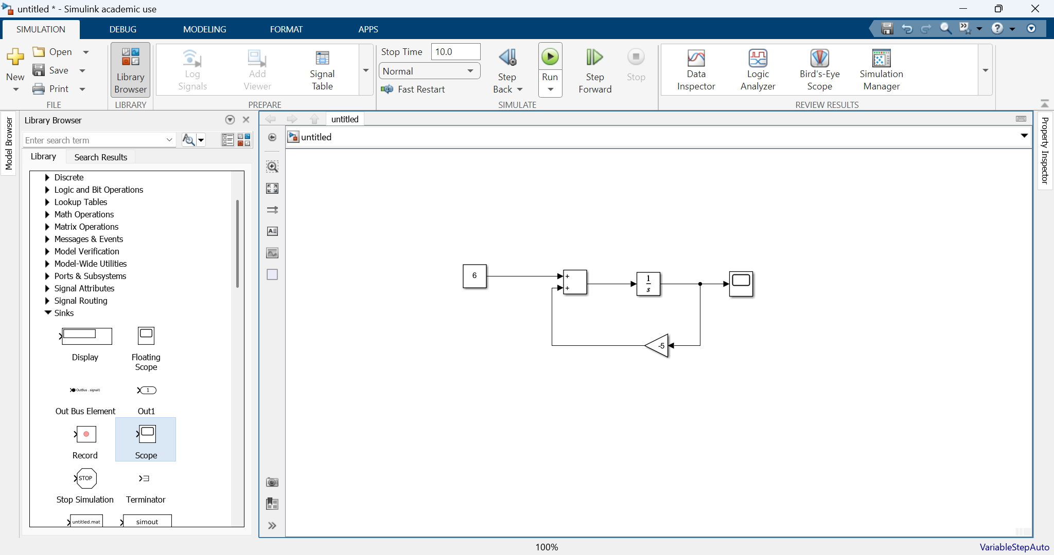
Figure 16 Final diagram

A useful habit is to read the model from the equation: the Sum output is dx/dt; the Integrator output is x; and the feedback branch creates -5x.

6.5 Running the simulation and viewing the result
Set a suitable Stop Time, for example 5 seconds, and click Run. Double-click the Scope to view x(t). The solution starts at x(0)=1 and rises rapidly towards 1.2 (=6/5), which is the equilibrium value obtained from 0 = 6 - 5x.
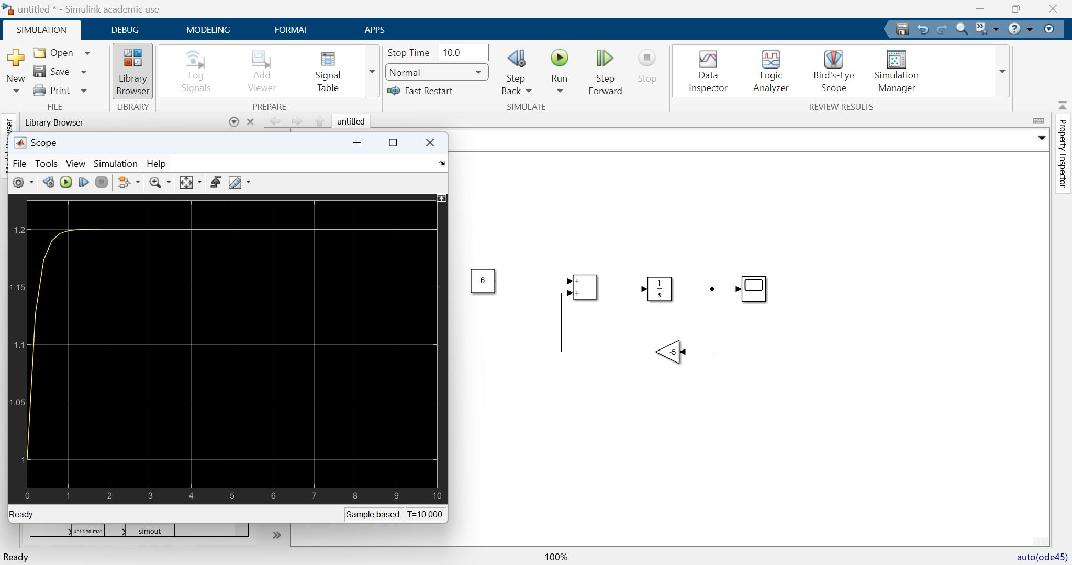
Figure 17 Response

Comparing the analytical and numerical solutions
The analytical expression and the Simulink response should lie on top of one another, apart from the very small numerical error introduced by the solver. The comparison below illustrates this.
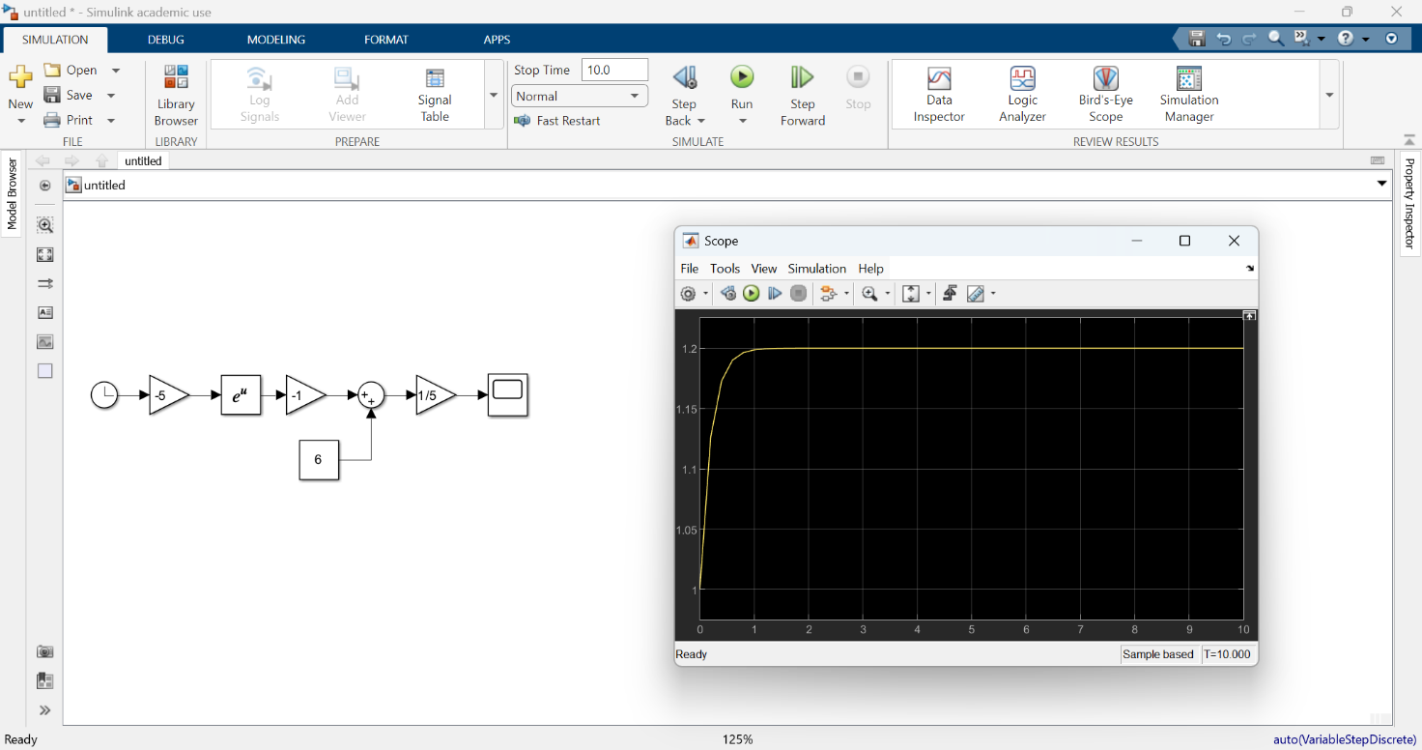
Figure 18 Analytical solution

6.6 A brief note about solvers
Simulink uses a numerical solver to advance the model through time. You will see settings for solver type, step size and error tolerances in Model Settings. For this introductory exercise, the default automatic solver settings are normally appropriate.
A smaller step size can improve the representation of rapidly changing signals, but it also requires more computation. More importantly, modern Simulink solvers may use variable step sizes and error tolerances, so there is no single step size such as 1 ms that is automatically 'best' for every model.
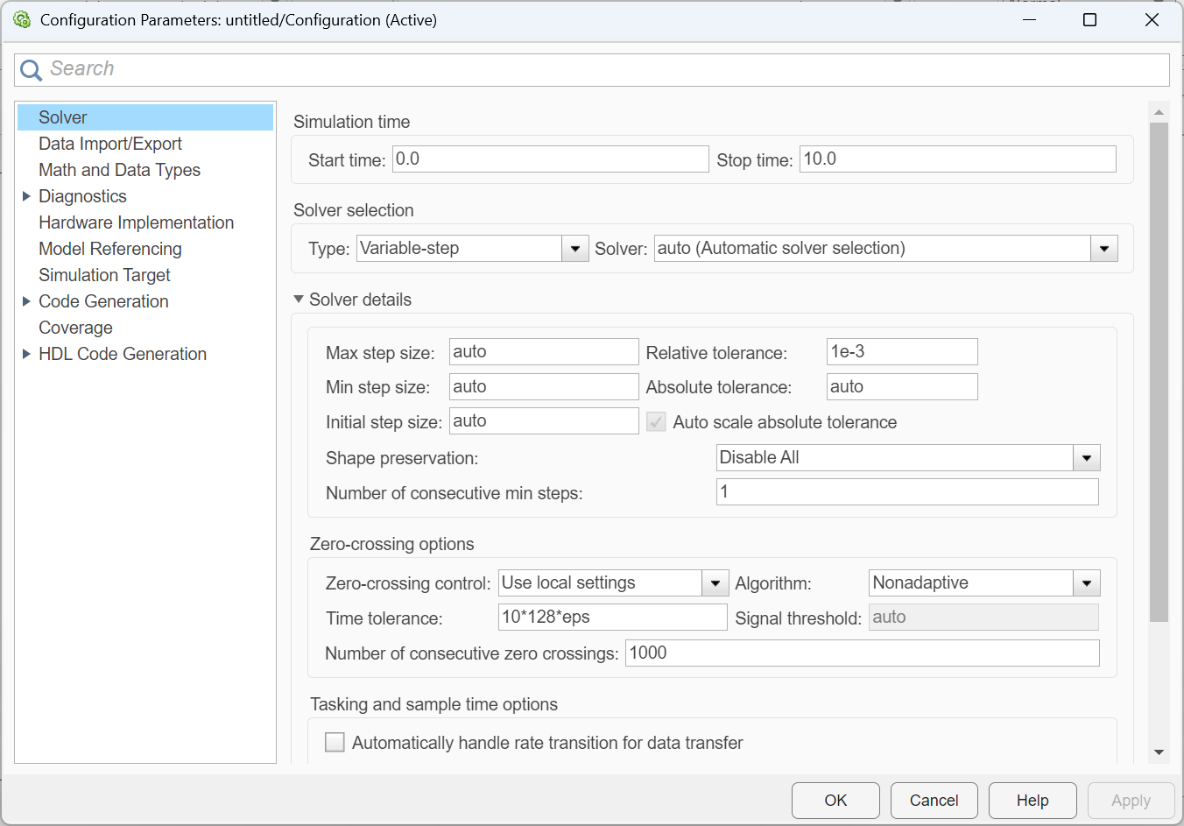
Figure 19 Simulink settings
At this stage, the main point is simply that the block diagram defines the mathematical model, while the solver determines how that model is calculated numerically.

6.7 Example: a third-order linear ODE
The same idea extends directly to higher-order systems. Consider
x''' + 6x'' + 11x' + 6x = 6, x(0)=0, x'(0)=0, x''(0)=0
Rearranging gives x''' = 6 - 6x'' - 11x' - 6x. A Simulink model therefore uses three Integrator blocks in series, with feedback from x'', x' and x through the appropriate gains.
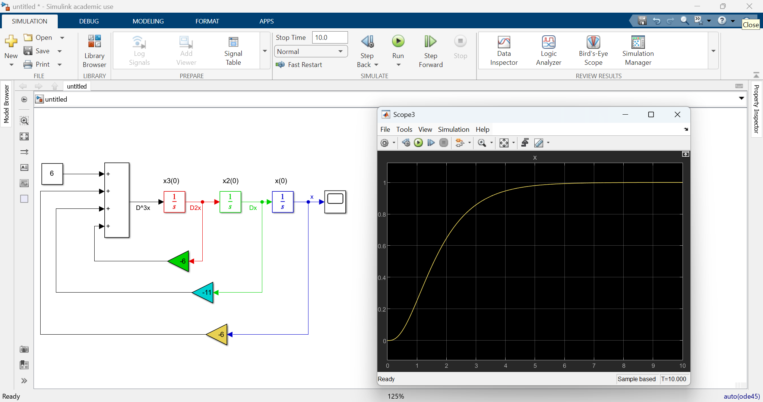
Figure 20 High order ODE

The output starts from zero and approaches the steady value x=1. This example illustrates how an nth-order ODE can be represented using n Integrator blocks
Notice that some blocks have different background and foreground colours. This is done via the option “Format”:
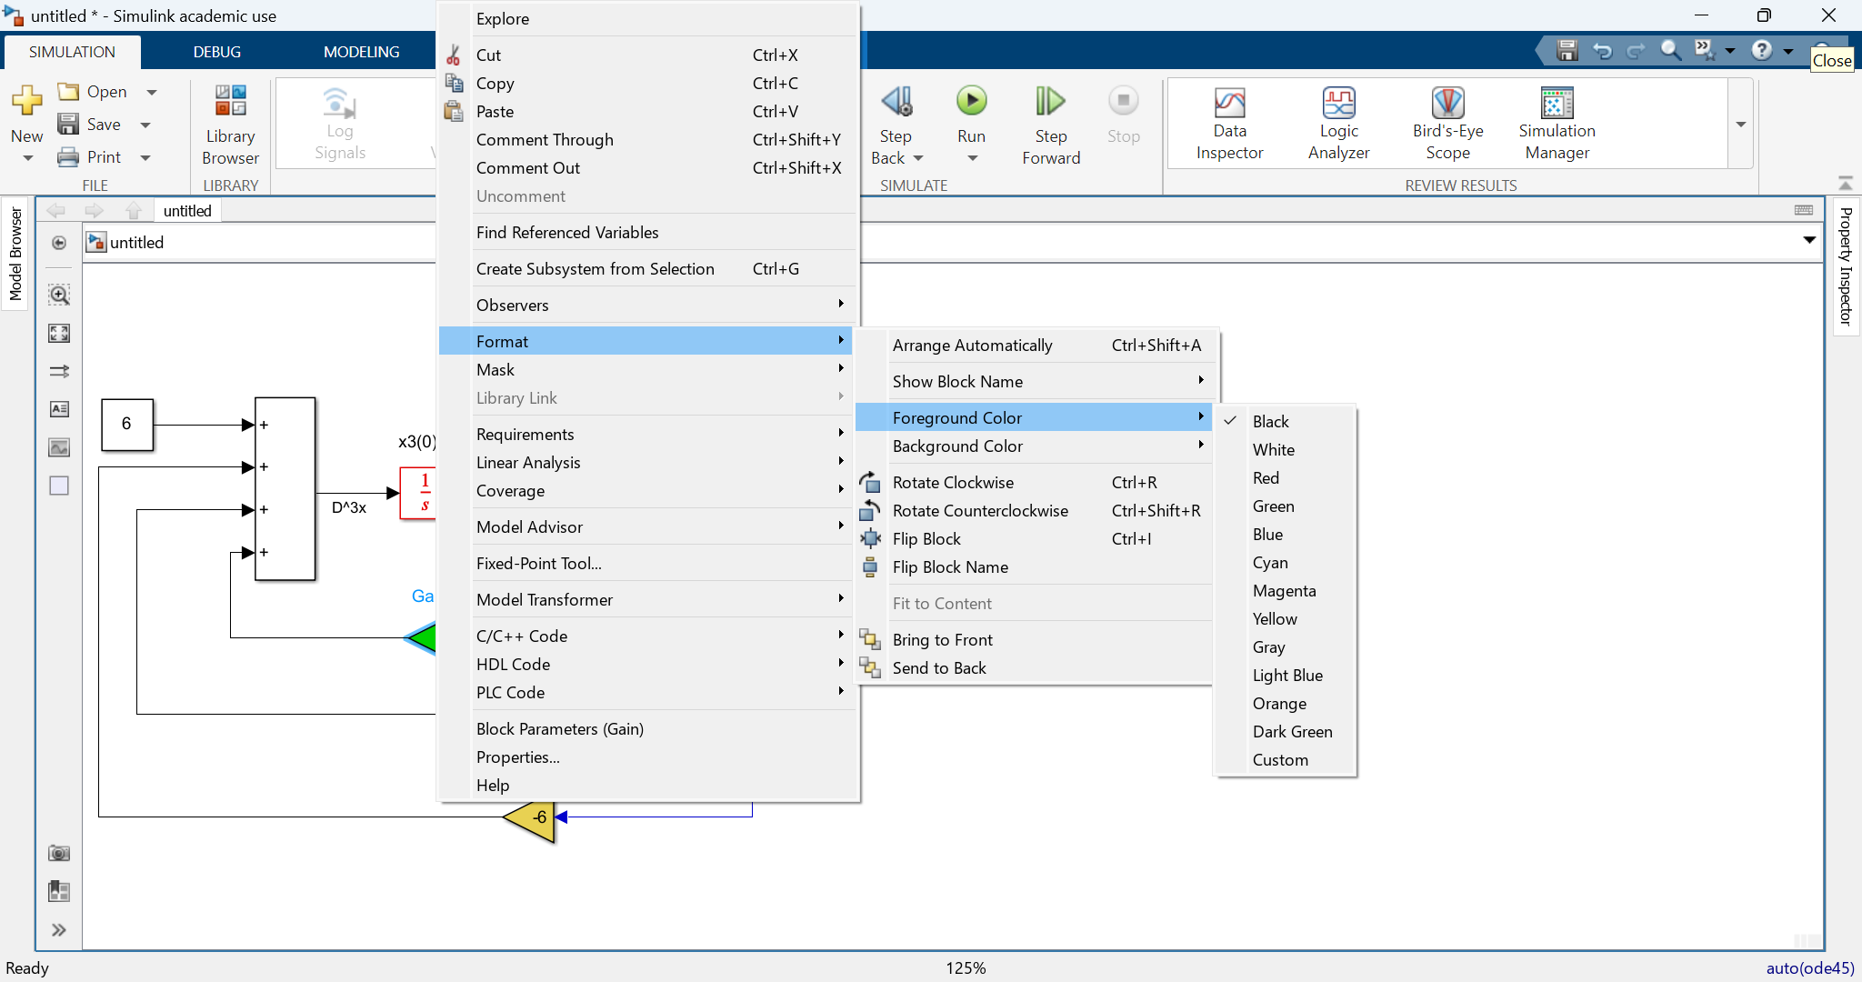
Figure 21 Changing the format of blocks

The text on top of the integrators that denote the initial conditions, are entered by just double clicking on an empty point in your model and selection to create the annotation:
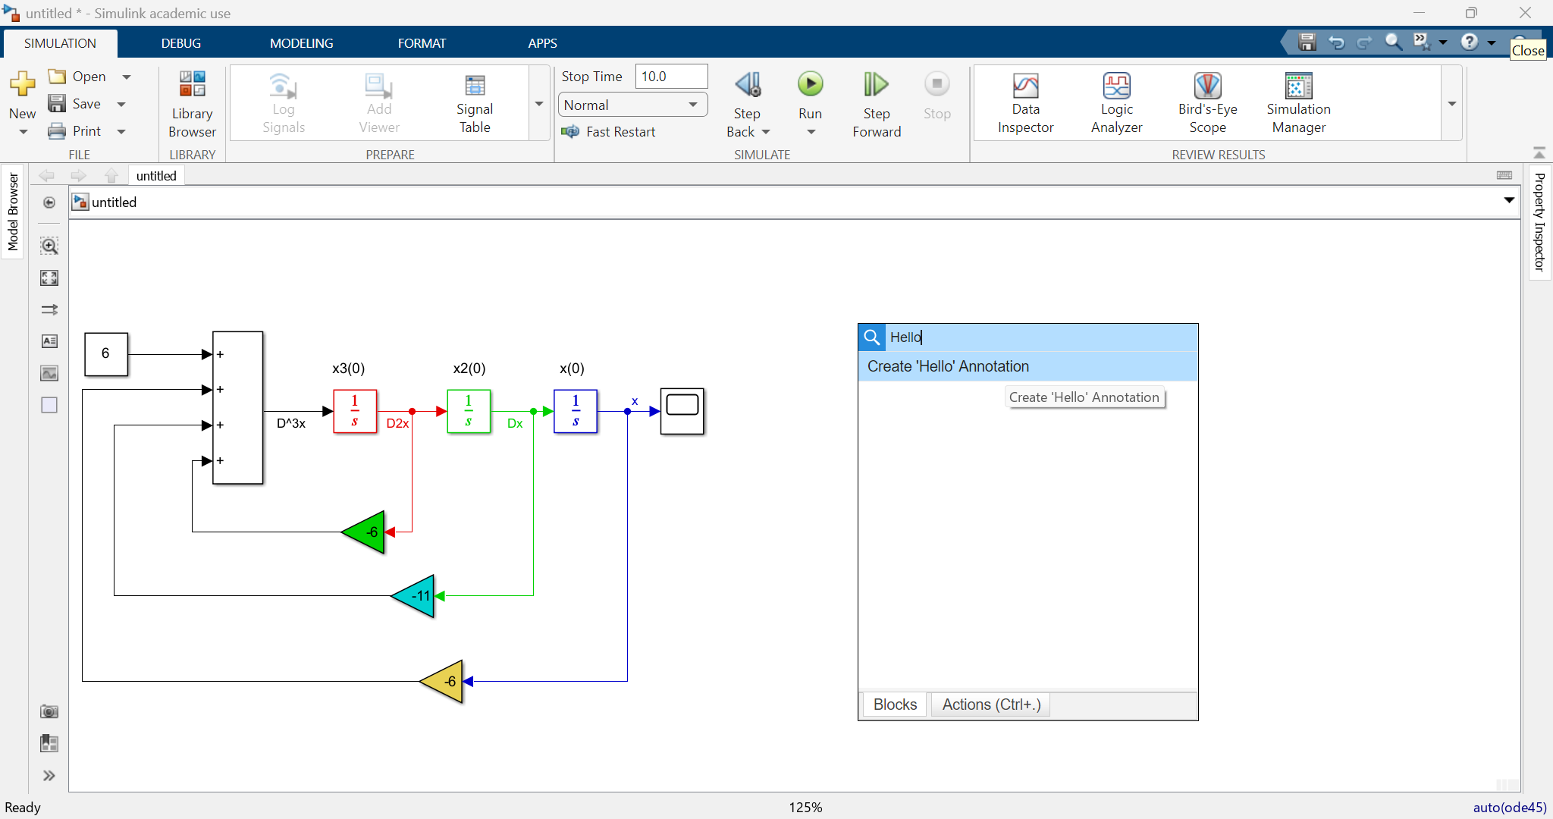
Figure 22 Adding annotations

6.8 Example: a first-order nonlinear ODE
Simulink is particularly useful when the differential equation is nonlinear. Consider
dx/dt = 2 - x², x(0)=0.5
The nonlinear term x^2 can be created using a square (or Product) block and fed back negative input of the Sum block:
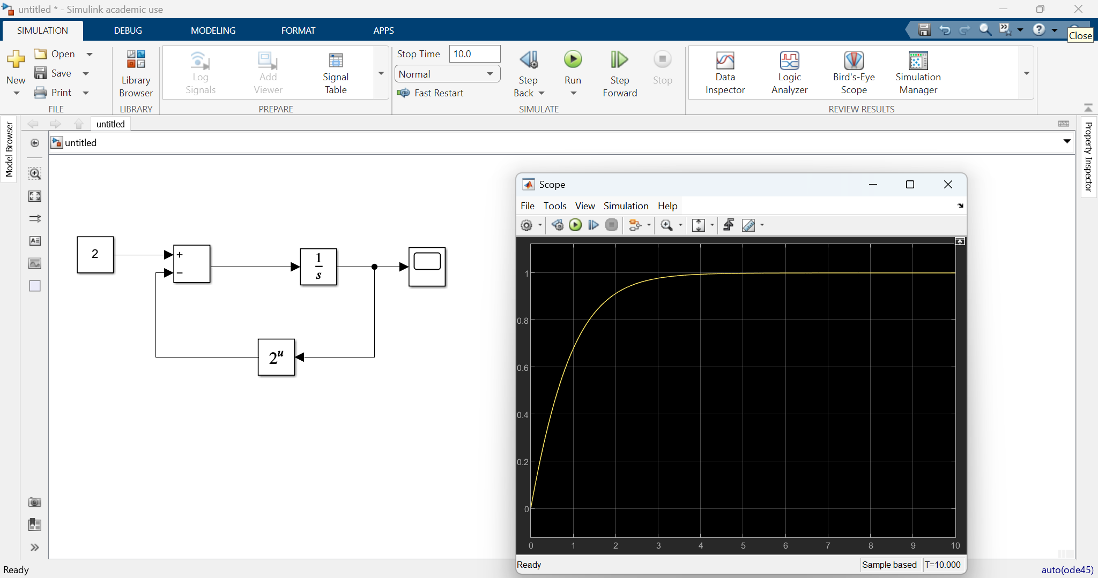
Figure 23 Nonlinear ODE

Chapter 6 summary
- Simulink represents dynamic systems using connected blocks and signals.
- Write an ODE with the highest derivative on the left before constructing the block diagram.
- Integrator blocks represent system states and contain their initial conditions.
- Constant, Sum and Gain blocks can be combined to construct the derivative of a state.
- A Scope displays how a signal changes during the simulation.
- Solver settings control the numerical calculation; the defaults are suitable for this first exercise.
- Analytical solutions, when available, are useful for checking a numerical Simulink model.
- Higher-order ODEs can be constructed using several Integrator blocks in series.
- Nonlinear terms can be represented using nonlinear mathematical blocks such as Product or Math Function.

Tutorial Exercise 6: Your first Simulink model
This exercise should take about 10 minutes. Work independently and use the model developed in the chapter as a guide. You do not need to write any MATLAB code.
Problem
Use Simulink to simulate
dx/dt + 2x = 4, x(0) = 0.5
for 5 seconds.
First find the analytical solution
Use the symbolic method from Chapter 5 before opening Simulink:
syms x(t)
dx = diff(x,t);
xsol = dsolve(dx + 2*x == 4, x(0) == 0.5)
Write down the exact solution and use it to predict the final value of x.
Tasks
1. Rearrange the equation into the form dx/dt = ...
2. Create a new Blank Model in Simulink.
3. Add one Constant, one Sum, one Gain, one Integrator and one Scope.
4. Set the Constant value, Gain value and Integrator initial condition from the equation above.
5. Connect the blocks so that the model calculates dx/dt and integrates it to obtain x.
6. Set the Stop Time to 5 seconds, run the simulation and open the Scope.
7. Compare the Scope response with the analytical solution. Do they agree?
Check before you finish
- The Scope should start at x = 0.5.
- The curve should rise smoothly.
- The final value should be close to 2.
If you finish early
Change the initial condition from 0.5 to 3 and run the model again. Predict what will happen before you press Run. Does the final value change?

